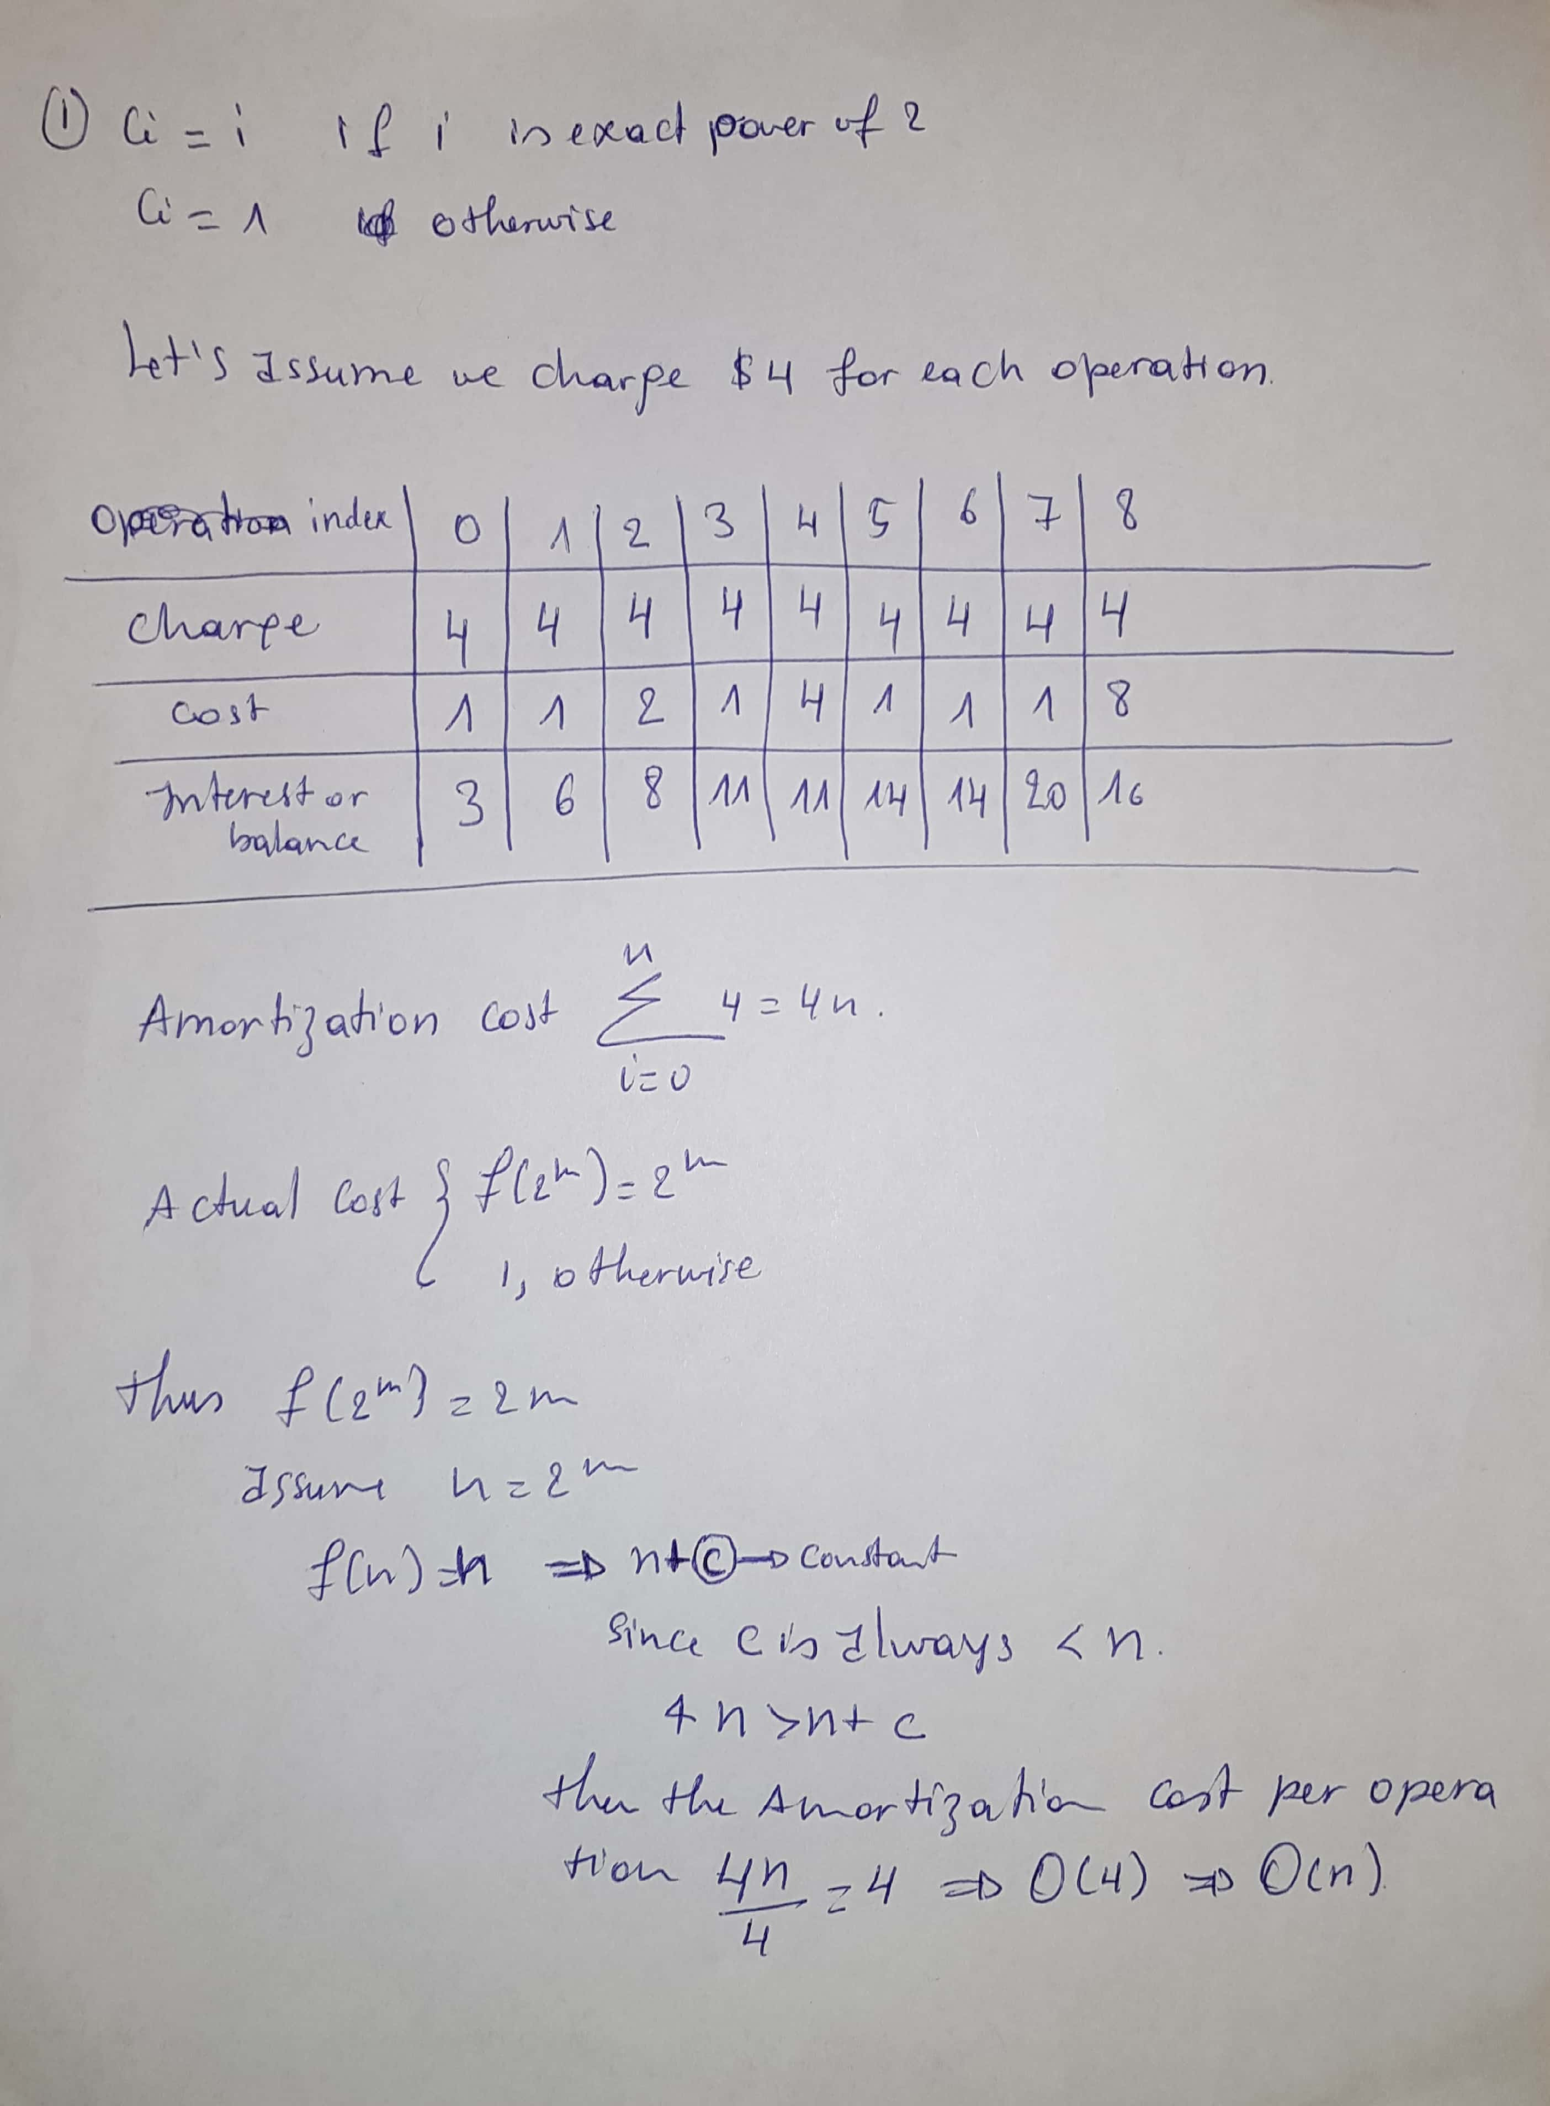
2. The java code:

public class BubbleSortImproved {
static int [] a = {2,5,1,6,9,4,42,35};
public static void main(String [] args) {
bubbleSort();
for(int k=0;k<a.length;k++) {
System.out.print(a[k]+" ");
}
}
public static void bubbleSort() {
int len = a.length;
for(int i = 0; i < len-1; ++i) {
if (a[i] < a[i + 1]) {
continue;
}
else {
for (int j = 0; j < len - 1; ++j) {
if (a[j] > a[j + 1]) {
swap(j, j + 1);
}
}
}
}
}
static void swap(int i, int j){
int temp = a[i];
a[i] = a[j];
a[j] = temp;
}
}
Our code running time is O(n) because, if the array is already sorted the inner loop will never be executed.

3. The java Code
public class BubbleSortImproved2 {
static int [] a = {2,5,1,6,9,4,42,35};
public static void main(String [] args) {
bubbleSort();
for(int k=0;k<a.length;k++) {
System.out.print(a[k]+" ");
}
}
public static void bubbleSort() {
int len = a.length;
for(int i = 0; i < len-1; ++i) {
for (int j = 0; j < len - 1-i; ++j) {
if (a[j] > a[j + 1]) {
swap(j, j + 1);
}
}
}
}
static void swap(int i, int j){
int temp = a[i];
a[i] = a[j];
a[j] = temp;
}
}
Instead of running the inner loop n times our code runs it n-i time for each iteration of the outer loop (Notice i is always increasing), Hence there will be a significant performance improvement.

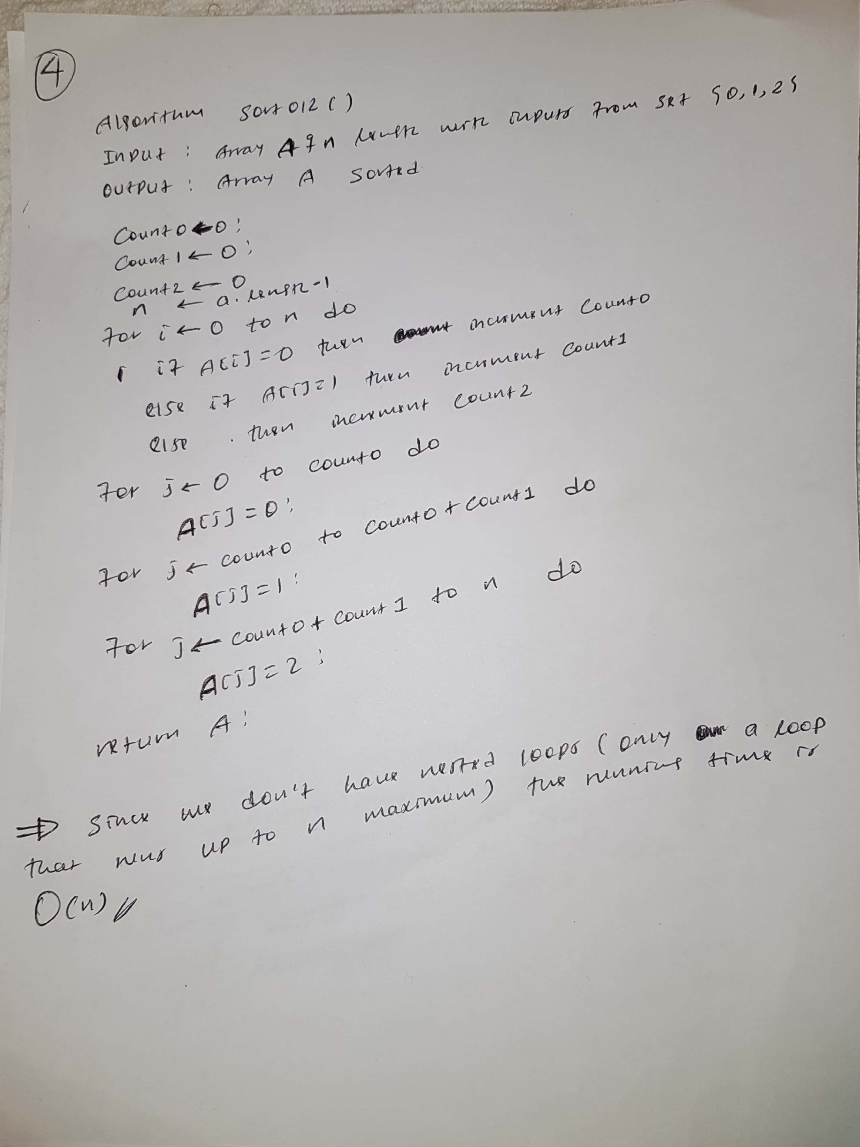
4.The java code:

public class Sort012 {
static int [] a={0,1,0,2};
public static void main(String [] args) {
sort012();
for(int i=0;i<a.length;i++) {
System.out.print(a[i]+" ");
}
}
public static void sort012() {
int count0=0,count1=0,count2=0;
for(int i=0;i<a.length;i++) {
if(a[i]==0) count0++;
else if(a[i]==1) count1++;
else count2++;
}
for(int j=0;j<count0;j++) {
a[j]=0;
}
for(int j=count0;j<(count0+count1);j++) {
a[j]=1;
}
for(int j=(count0+count1);j<a.length;j++) {
a[j]=2;
}
}
}

